**Agmarks Android App Documentation**



**PROJECT SPECIFICATIONS**

1. Introduction
2. Business Requirements
3. Product & Technical Requirements
4. Process work flow (with UI-User Interface)
5. Time Lines
6. **Introduction**

Astona Private Limited is an esteemed Independent organization where we develop our own product, and the product is Agmarks.com

Agmarks.com is designed, developed and wholly owned by Astona Private Limited. Agmarks is committed to provide a best in a class integrated ecosystem for agriculture & allied activities, animal husbandry and dairy products.

Agmarks is committed to streamline all farm & subsidiary activities and address supply chain issues. The company is providing a free service platform for the farmers and a marketplace for all other stakeholders. By using technology and timely service, Agmarks strives to get high yield and the Maximum Possible Price (MxPP) to sustain farmer, thereby securing food for future generations.

Agmarks.com web application development is in progress and we are looking for a Mobile/Android Application.

1. **Business Requirements**

We need an Android native application that reflects our vision & mission, our website and business logic.

The App should be User Friendly, stable, robust and simple.

1. **Product & Technical Requirements**

* Fonts to be used for: Headings – EB Garamond(semi bold-600), Content – Roboto/Dosis/Nunito & Button Links: Catamaran/Signika

Reference: https://fonts.google.com

* Icons(512 x 512.png) will be provided by mail
* Images will be provided by mail
* UI Design Elements will be provided by mail

1. **Process Work flow**

**Screen1:**



App Opening Screen with Progress bar

**Screen 2:**



Here Select Language should be in native language (font)

**Screen 3:**

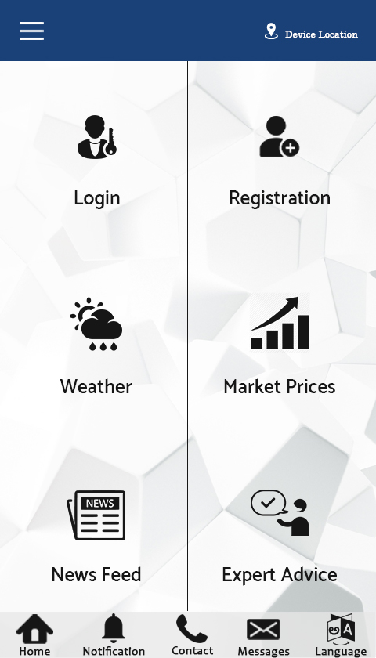

Landing Page with six tiles, Footer with 5 icons

For Above differentiating Line colour code: #e7e7e7

**Colour Code for header: #1a4178**

**Screen 4: 1st Tile Login Page**

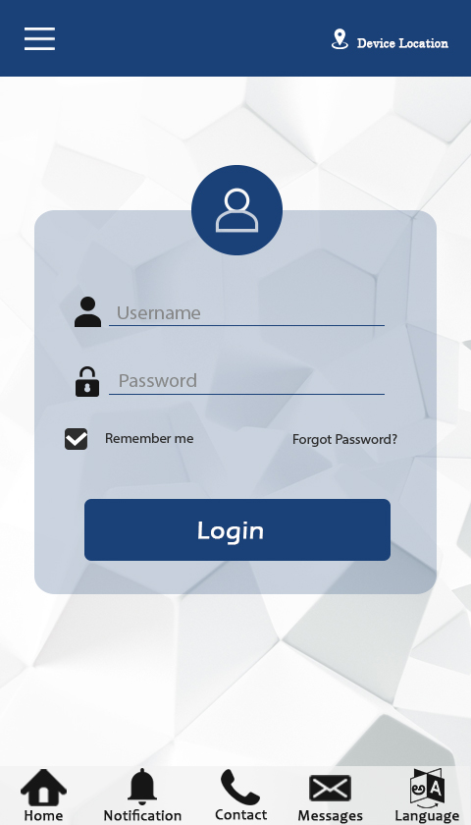

**Screen 5: 2nd Tile Registration Page**

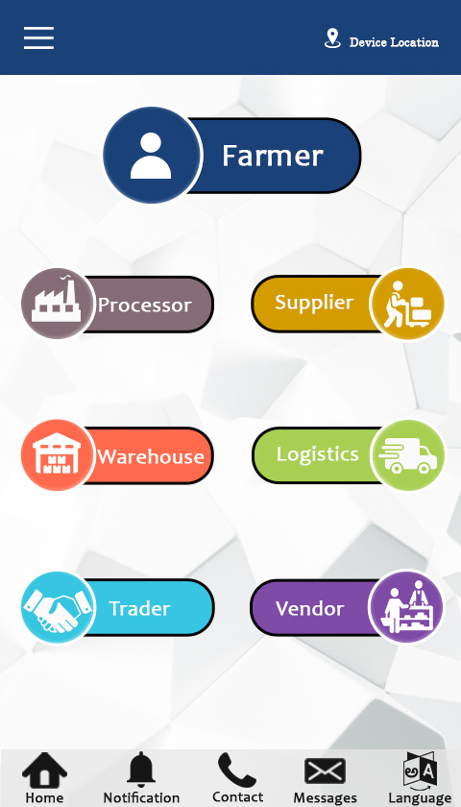

**Screen 6: 3rd Tile Weather Forecast**

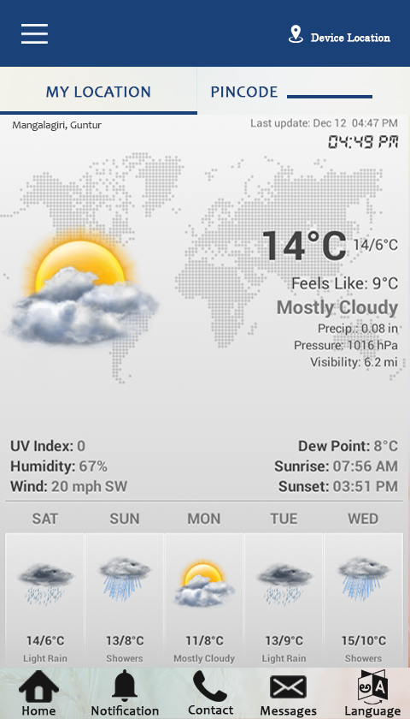

**Screen 7: 4th Tile Market Prices Categories Page**

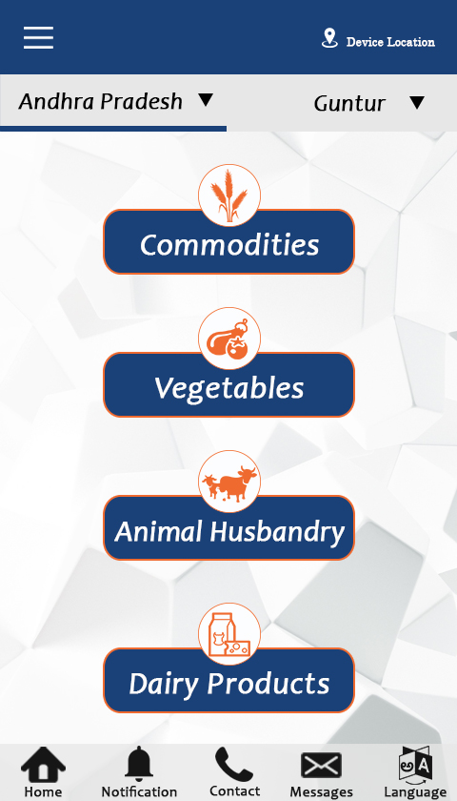

**Description**: For this page, it should display based on device location and if they want to see other district Market prices on selecting District Dropdown. In this page they can click any of the button to display Market, Commodity, Variety etc will be shown in table.

**Screen 7-1: 1st Tile Market Prices Commodity Page**

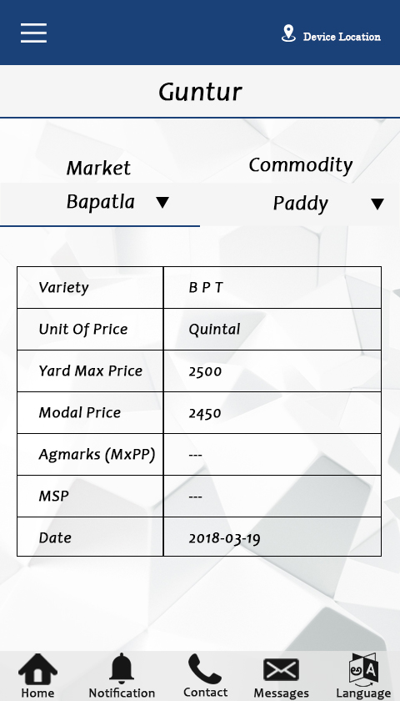

**Description:** After Selecting State and District it should display District as a heading and they can select Market and Commodity type to display table. Market and Commodity should come from table.

**REGISTRATIONS**

**FORMS & VALIDATIONS**

**FARMER:**

**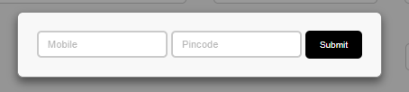**

**Before Entering into the forms it is mandatory to enter the Mobile & Pin code**

1. Mobile: Should enter only 10 digit numeric number, do not allow Alpha Numeric and Special characters.
2. Pin code: Should enter only 6 digit numeric number, do not allow Alpha Numeric and Special characters

name_vali_farm

1. Name & Sur Name: Should enter only Characters (Mandatory Fields)

ph_farm

1. Phone: It should appear the same number after entering into the Farmer form, it should not editable.

adar_farm

1. Aadhar: should enter only 12 digit Numeric Number, not a Mandatory Field, should not allow Alpha Numeric and Special characters

addre_farm

1. Pin code: It should appear the same pin code after entering into the Farmer form, this field is non editable.
2. Mandal, District & State: It should appear based on Pin code, these fields are non-editable (Disabled). (Mandatory Fields)



1. Crop: He can select only 5 Crops from the list and should come from database, this crops list should be based on selected district. (give autofill option and multiple selection)
2. Vegetables: He can select only 8 Vegetables from the list and should come from database, this vegetables list should be based on selected district. (give autofill option and multiple selection)
3. Animal Husbandry: He can select only 3 animals from the list and should come from database. (give autofill option and multiple selection)
4. Dairy (Milk Products): He can select only 3 dairy products from the list and should come from database. (give autofill option and multiple selection)

\*If you do not find any Crops, Vegetables, Animal Husbandry or Dairy Products in the below list. Please contact or mail to us.

---Once Completing Farmer Registration and send OTP (User will be his Mobile Number and for password we will send 4 digit pin as a password)

**PROCESSOR:**

****

1. Mobile: to enter into form Mobile number is mandatory field.

radio_pro

1. Choose any one to enrol as a Processor, whether it is Company or Individual

**-----Registering as a Company----**

1. Company Name, Address, Pin code, Village, Mandal fields are mandatory
2. Pin code: Should enter only 6 digit numeric number, do not allow Alpha Numeric and Special characters, and after inserting pin code District and State Name appear on their filed.
3. Email: This field is Mandatory
4. DOB and GST Number: Optional

commo-pro

1. Ram Materials: He can select 2 raw materials, list should come from database. (give autofill option and multiple selection)
2. Finished Products: He can add only 3 Finished Products
3. Packaging: He can add only 3 Packaging

**-----Registering as Individual----**

1. Name, Sur Name, Address, Pin code, Village and Mandal: Fields are mandatory
2. Ram Materials: He can select 2 raw materials, list should come from database. (give autofill option and multiple selection)
3. Finished Products: He can add only 3 Finished Products
4. Packaging: He can add only 3 Packaging

**Warehouse:**

****

1. Mobile: to enter into form Mobile number is mandatory field.

C:\Users\Astona 2\AppData\Local\Microsoft\Windows\INetCache\Content.Word\radio_pro.png

1. Choose any one to enrol as a Warehouse, whether it is Company or Individual

**-----Registering as a Company----**

1. Company Name, Address, Pin code, Village, Mandal fields are mandatory
2. Pin code: Should enter only 6 digit numeric number, do not allow Alpha Numeric and Special characters, and after inserting pin code District and State Name appear on their filed.
3. Email: This field is Mandatory
4. DOB and GST Number: Optional



1. Crop: He can select unlimited Crops, list should come from database. (give autofill option and multiple selection)
2. Vegetables: He can select unlimited Vegetables, list should come from database. (give autofill option and multiple selection)
3. Animal: He can select unlimited Animal, list should come from database. (give autofill option and multiple selection)
4. Dairy: He can select unlimited Dairy, list should come from database. (give autofill option and multiple selection)

stora_ware

1. Storage Capacity: this is Mandatory field.

**-----Registering as Individual----**

1. Name, Sur Name, Address, Pin code, Village and Mandal: Fields are mandatory



1. Crop: He can select unlimited Crops, list should come from database. (give autofill option and multiple selection)
2. Vegetables: He can select unlimited Vegetables, list should come from database. (give autofill option and multiple selection)
3. Animal: He can select unlimited Animal, list should come from database. (give autofill option and multiple selection)
4. Dairy: He can select unlimited Dairy, list should come from database. (give autofill option and multiple selection)
5. Storage Capacity: this is Mandatory field.

C:\Users\Astona 2\AppData\Local\Microsoft\Windows\INetCache\Content.Word\stora_ware.png

**Trader:**

****

1. Mobile: to enter into form Mobile number is mandatory field.

C:\Users\Astona 2\AppData\Local\Microsoft\Windows\INetCache\Content.Word\radio_pro.png

1. Choose any one to enrol as a Trader, whether it is Company or Individual

**-----Registering as a Company----**

1. Company Name, Address, Pin code, Village, Mandal fields are mandatory
2. Pin code: Should enter only 6 digit numeric number, do not allow Alpha Numeric and Special characters, and after inserting pin code District and State Name appear on their filed.
3. Email: This field is Mandatory
4. DOB and GST Number: Optional



1. Crop: He can select 5 Crops, list should come from database. (give autofill option and multiple selection)
2. Vegetables: He can select 8 Vegetables, list should come from database. (give autofill option and multiple selection)
3. Animal: He can select 3Animal, list should come from database. (give autofill option and multiple selection)
4. Dairy: He can select 3 Dairy, list should come from database. (give autofill option and multiple selection)

**-----Registering as Individual----**

1. Name, Sur Name, Address, Pin code, Village and Mandal: Fields are mandatory



1. Crop: He can select 5 Crops, list should come from database. (give autofill option and multiple selection)
2. Vegetables: He can select 8 Vegetables, list should come from database. (give autofill option and multiple selection)
3. Animal: He can select 3 Animal, list should come from database. (give autofill option and multiple selection)
4. Dairy: He can select 3 Dairy, list should come from database. (give autofill option and multiple selection)

**Supplier:**

****

1. Mobile: to enter into form Mobile number is mandatory field.

C:\Users\Astona 2\AppData\Local\Microsoft\Windows\INetCache\Content.Word\radio_pro.png

1. Choose any one to enrol as a Supplier, whether it is Company or Individual

**-----Registering as a Company----**

1. Company Name, Address, Pin code, Village, Mandal fields are mandatory
2. Pin code: Should enter only 6 digit numeric number, do not allow Alpha Numeric and Special characters, and after inserting pin code District and State Name appear on their filed.
3. Email: This field is Mandatory
4. DOB and GST Number: Optional



1. Bio: He can select Unlimited Bio, list should come from database. (give autofill option and multiple selection)
2. Botanical: He can select Unlimited Botanical, list should come from database. (give autofill option and multiple selection)
3. Farm Machinery: He can select Unlimited Farm Machinery, list should come from database. (give autofill option and multiple selection)
4. Inorganic: He can select Unlimited Inorganic, list should come from database. (give autofill option and multiple selection)
5. Organic: He can select Unlimited organic, list should come from database. (give autofill option and multiple selection)
6. Seed: He can select Unlimited Seed, list should come from database. (give autofill option and multiple selection)

**-----Registering as Individual----**

1. Name, Sur Name, Address, Pin code, Village and Mandal -- Fields are mandatory



1. Bio: He can select Unlimited Bio, list should come from database. (give autofill option and multiple selection)
2. Botanical: He can select Unlimited Botanical, list should come from database. (give autofill option and multiple selection)
3. Farm Machinery: He can select Unlimited Farm Machinery, list should come from database. (give autofill option and multiple selection)
4. Inorganic: He can select Unlimited Inorganic, list should come from database. (give autofill option and multiple selection)
5. Organic: He can select Unlimited organic, list should come from database. (give autofill option and multiple selection)
6. Seed: He can select Unlimited Seed, list should come from database. (give autofill option and multiple selection)

**Logistics:**

****

1. Mobile: to enter into form Mobile number is mandatory field.

C:\Users\Astona 2\AppData\Local\Microsoft\Windows\INetCache\Content.Word\radio_pro.png

1. Choose any one to enrol as a Logistics, whether it is Company or Individual

**-----Registering as a Company----**

1. Company Name, Address, Pin code, Village, Mandal fields are mandatory
2. Pin code: Should enter only 6 digit numeric number, do not allow Alpha Numeric and Special characters, and after inserting pin code District and State Name appear on their filed.
3. Email: This field is Mandatory
4. DOB and GST Number: Optional
5. Mandatory Fields are: Select Vehicle Type & Capacity of Vehicle(in the form of units)

vehi_logi

**-----Registering as Individual----**

1. Name, Sur Name, Address, Email, Pin code, Village and Mandal, Select Vehicle Type & Capacity of Vehicle (in the form of units) Fields are mandatory.

**Vendor:**

****

1. Mobile: to enter into form Mobile number is mandatory field.

C:\Users\Astona 2\AppData\Local\Microsoft\Windows\INetCache\Content.Word\radio_pro.png

1. Choose any one to enrol as a Vendor, whether it is Company or Individual

**-----Registering as a Company----**

1. Company Name, Address, Pin code, Village, Mandal fields are mandatory
2. Pin code: Should enter only 6 digit numeric number, do not allow Alpha Numeric and Special characters, and after inserting pin code District and State Name appear on their filed.
3. Email: This field is Mandatory
4. DOB and GST Number: Optional

comm_vend

1. Vegetables: He can select 8 Vegetables, list should come from database. (give autofill option and multiple selection)
2. Animal: He can select 3 Animals, list should come from database. (give autofill option and multiple selection)
3. Dairy: He can select 3 Dairy, list should come from database. (give autofill option and multiple selection)

**-----Registering as Individual----**

1. Name, Sur Name, Address, Pin code, Village and Mandal: Fields are mandatory

C:\Users\Astona 2\AppData\Local\Microsoft\Windows\INetCache\Content.Word\comm_vend.png

1. Vegetables: He can select 8 Vegetables, list should come from database. (give autofill option and multiple selection)
2. Animal: He can select 3 Animals, list should come from database. (give autofill option and multiple selection)
3. Dairy: He can select 3 Dairy, list should come from database. (give autofill option and multiple selection)

**RESTRICTIONS FOR REGISTRATIONS**

We are giving 4 maximum registration for a single person (i.e. based on Unique Phone Number)

For more details visit [www.agmarks.co.in](http://www.agmarks.co.in) (you can test in detail) is a testing portal.